**Overview**

Today’s tutorial introduces you to R, and suggests some best practices for writing readable, and reproducible code. We will use RStudio, an Interactive Development Environment (IDE) that wraps around R so you don’t have to use the terminal.

There are various file formats you typically use within RStudio. To start, we will use R Markdown, which generally refers to a document that is written in Markdown () with embedded chunks of R code. This website contains additional information about R markdown, which may come in handy later on: <http://rmarkdown.rstudio.com/articles_intro.html>

**Learning Objectives**

The instructions below will summarize how to set up RStudio, and guide you through an introductory tutorial using an R Markdown file. By the end of this tutorial, you will be able to:

1. Navigate RStudio
2. Understand the difference between R scripts and R Markdowns
3. Print the current working directory, distinguish between absolute and relative paths
4. Install and load libraries in R
5. Load sample data, view the contents of a table, and manipulate the data using basic functions
6. Save output to a directory of your choice
7. Trace a workflow for debugging any issues you encounter

**Supporting files required**

* getting_started_with_R.pdf
* getting_started_with_R.Rmd
* sample_data_seminar0a.txt

**GETTING STARTED: Installing RStudio and opening the RMarkdown file**

1. **Install RStudio** 
   1. Go to the following link and install RStudio for your Operating System.
      1. https://www.rstudio.com/products/rstudio/download2/
      2. Choose RStudio Desktop (Open Source License)
   2. Open RStudio.
2. **Understand what you see** 
   1. RStudio is comprised of various elements – the Editor, Workspace, Console, and Plots windows. The Editor lets you edit and save scripts, the Workspace tracks the data and values in R memory, you execute commands in the Console, and can use the Files/Plots/Packages/Help area to navigate dirs, view graphs, or use the help function.

**Console: Execute R commands here**

Make a new Rscript/Rmarkdown file, open an existing file

Navigate local directories, visualize graphs, track installed packages, search available documentation on installed packages and commands.

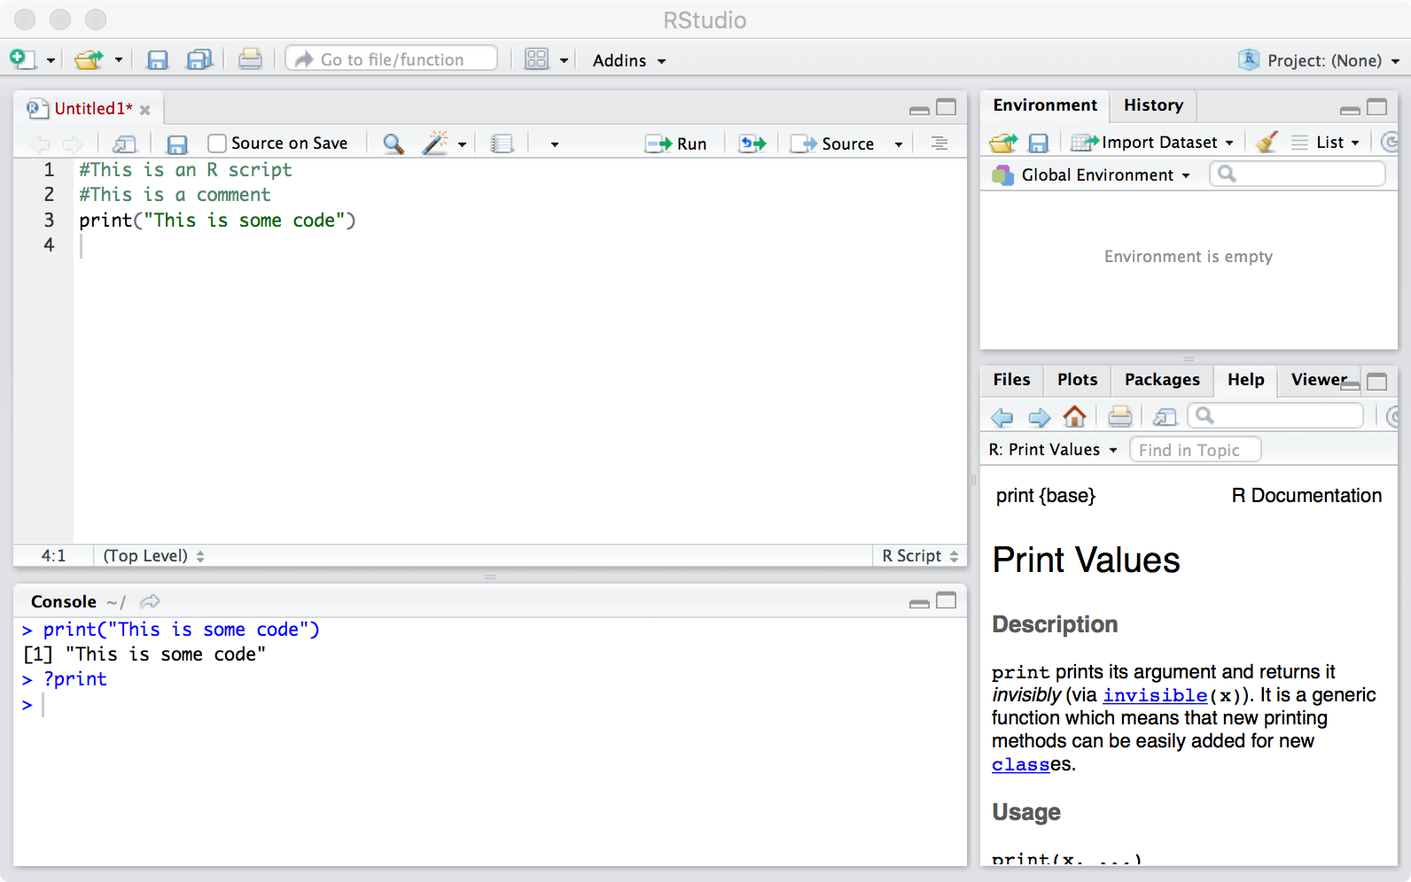

**Editor**

**Plots**

**Workspace**

1. **Playing around with the R Console**
   1. R is an interactive language. This means that you type a command, press Enter to execute it, and see the result (if there is anything to print from your command).
   2. In the code above, we have run the command ‘**print(“This is some code”)**’ *in the console*, and can see the output immediately.
2. **Open the R markdown document for an introduction to RStudio**
   1. For the remainder of this tutorial, the code and supporting explanations have been put together for you in an R Markdown. An R Markdown lets you lets you generate reproducible, readable reports (like the one accompanying this guide!), conveniently and dynamically. You can 'knit' a .Rmd file into an html document, a pdf, a word doc, or an intermediate markdown file - without having to use a fancy converter.
   2. In the **Seminar0a** folder, you should see 2 files:
      1. *getting_started_with_R.Rmd*
      2. *getting_started_with_R.pdf*
   3. You can open the .Rmd file in RStudio, or just follow along with the .pdf document.
      1. If this is your first time using R, we suggest you read through *getting_started_with_R.pdf* to familiarize yourself with the overall outline first.
      2. You will see something like the following when you open the .Rmd file:

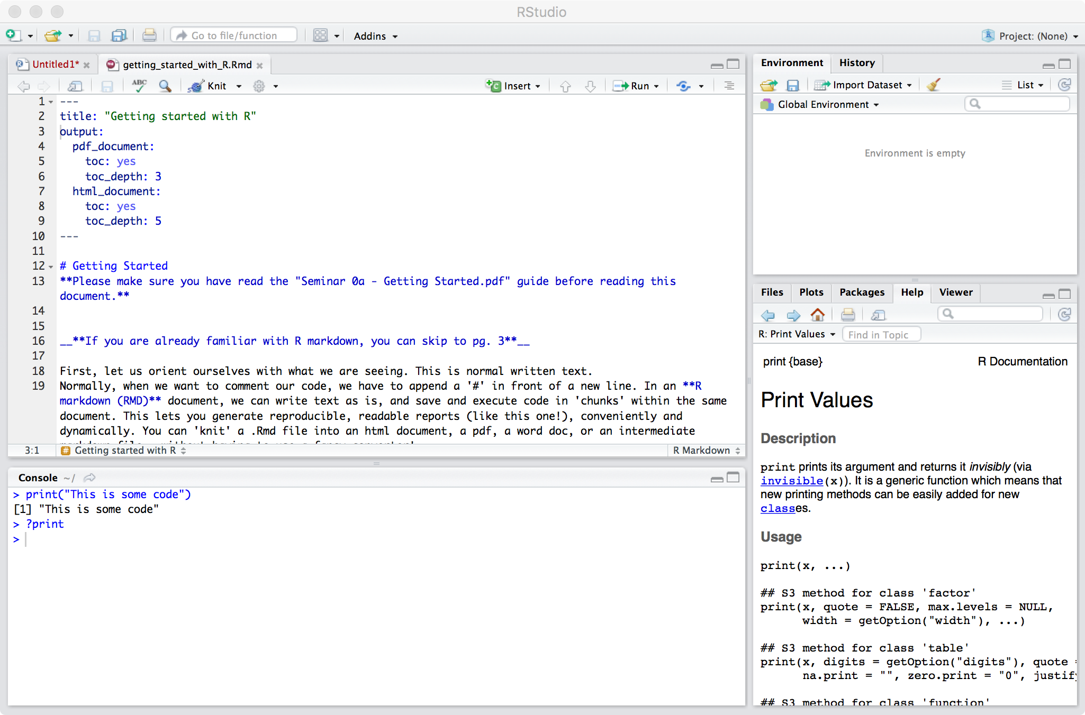

1. **Run code within the R Markdown**
   1. You can run a **chunk of code** by clicking in the area and selecting the option ‘Run Current Chunk’. You can compile the **entire document** in different output formats using the ‘knit’ option.

*You can also ‘knit’ the entire document into a pdf/html/doc format, using this option*

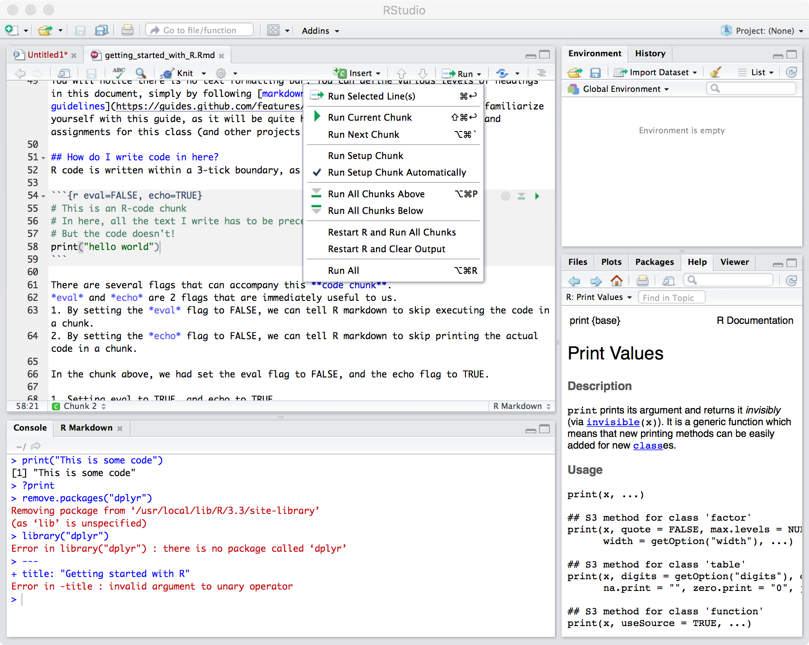

Click here to run the chunk

Navigate cursor to code chunk

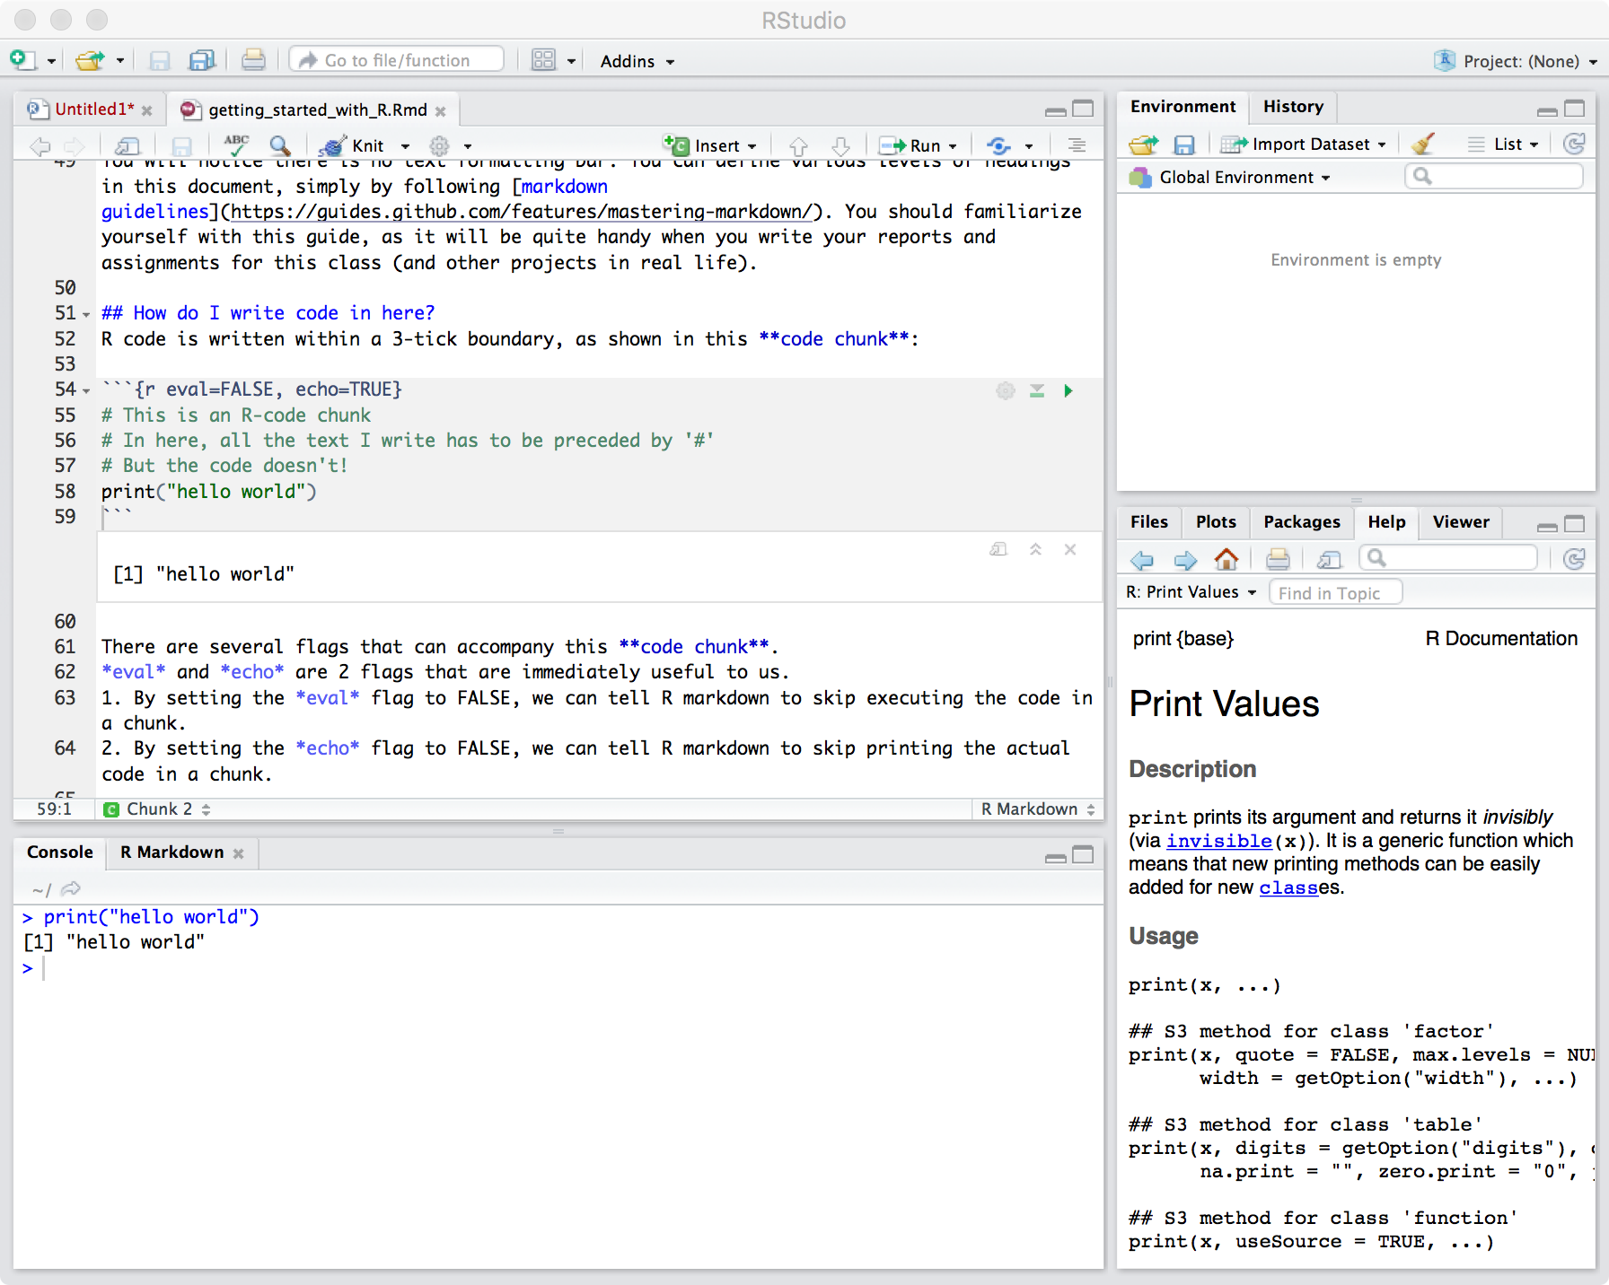

The output from running the code is shown both in the console and within the .Rmd file